| Course name | Numerical Modeling & Simulation in Scilab Xcos |
| --- | --- |
| **Lesson name** | **Numerical Modelling of Ather Energy 450 using FTP Drive Cycle data in Scilab-Xcos** |
| **Lesson objective** | **Practice blocks &** **acquaint to use GUI of Scilab-Xcos** |
| Created by | Bharath Kumar P |

**Problem statement:** Model Ather Energy 450 for FTP Drive Cycle in Scilab Xcos to plot the Wheel Torque, Wheel Speed, Motor Torque, Motor Speed and Battery Current in Scilab-Xcos.

**FTP Drive Cycle Graph:**

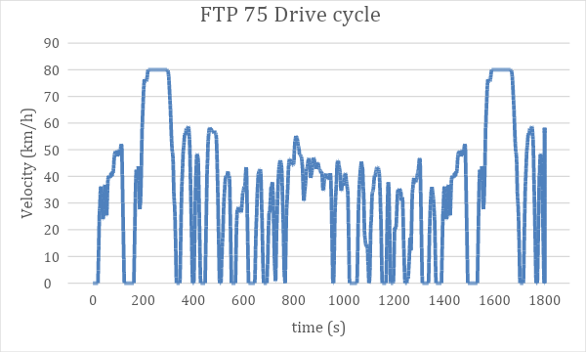

**Model Inputs:**

| **Sl No** | **Parameter** | **Value** | **Units** |
| --- | --- | --- | --- |
|  | 1. **Chassis** |  |  |
|  | 1. Coefficient of rolling resistance | 0.015 |  |
|  | 1. Mass of Vehicle | 111 | Kg |
|  | 1. Mass of Driver | 80 | Kg |
|  | 1. Gravity constant | 9.81 | m/s |
|  | 1. Grade Angle | 0 | degree |
|  | 1. Velocity | From the FTP Drive Cycle data | Kmph |
|  | 1. Area | 0.875 | m^2 |
|  | 1. Air Density | 1.225 | Kg/m^3 |
|  | 1. Drag Coefficient | 0.22 |  |
|  | 1. Radius of wheel | 0.1524 | m |
|  | 1. **Transmission** |  |  |
|  | 1. Gear Ratio | 7.8 |  |
|  | 1. Transmission Efficiency | 85 | % |
|  | 1. **Motor** |  |  |
|  | Motor Efficiency | 90 | % |
|  | 1. **Battery** |  |  |
|  | 1. Motor Controller Efficiency | 85 | % |
|  | 1. Battery Capacity | 2400 | Wh |
|  | 1. Battery Voltage | 51.1 | V |
|  | 1. FTP drive cycle distance | 17.5 | Km |
|  | 1. Battery Initial SOC | 100 | % |
|  | 1. Drive Cycle time or Simulation time | 1180 | s |
|  | 1. **Cell** |  |  |
|  | 1. Cell Voltage | 3.6 | V |
|  | 1. Cell Capacity | 2.7 | Ah |